

CE/CZ1003 Introduction to Computational Thinking

**Project Assignment Report**

“NTU Project Accelerator” Telegram Bot

Team Members

1. Li Guanlong
2. Ma Xiao
3. Deng Zichao
4. Lim Yao Xiong
5. Han Simeng

Table of Contents

1. Introduction 3

2. Problem Statement 4

3. Proposed Solutions 5

3.1 Flowchart 5

3.2 Functions 6

4. Limitations & Constraints 8

5. Conclusion 10

# 1. Introduction

As we all know, projects are very crucial in the students’ university academic lives. However, to ensure that the project works out well, it does not only take a brilliant idea. Various issues arise like finding the right team and also the limitation of specific knowledges which will greatly limit the direction and success of the project.

For example, students may have excellent ideas or proposals in mind but they are unable to find suitable teammates to collaborate with, which means that the students do not know who else will share the same interest as them.

What’s more, some students are not as creative as the others and are unable to come up with genius project ideas. In this case, they are on a look out to for inspiration, be it online, or past proposed project ideas and probably the latest technology on the news. Some students might even consider joining other groups with an interesting project.

Our telegram bot, “NTU Project Accelerator”, creates a platform mainly for NTU students to share their project ideas and get inspired by some latest technology news and existing project demonstrations.

Therefore, by using our bot, various genius ideas can be connected and conquered together, which will lead to more creativity and innovation.

# 2. Problem Statement

* Do you always have a genius idea in mind but you can’t seem to find teammates to make it come true?
* Do you love getting inspired by the latest technology news and already proposed project examples?
* Do you want and easier way out, which is to join groups that have proposed an interesting project?
* Our bot, “NTU Project Accelerator”, connects you to people who share the same ideas and same passion for technology with you and links you to a large number of project information and technology resources.
* Search “M13456” on telegram and become a technology geek with the help of our bot.
* We are “Connect, Combat and Conquer” for your academic projects.

# 3. Proposed Solutions

3.1 Flowchart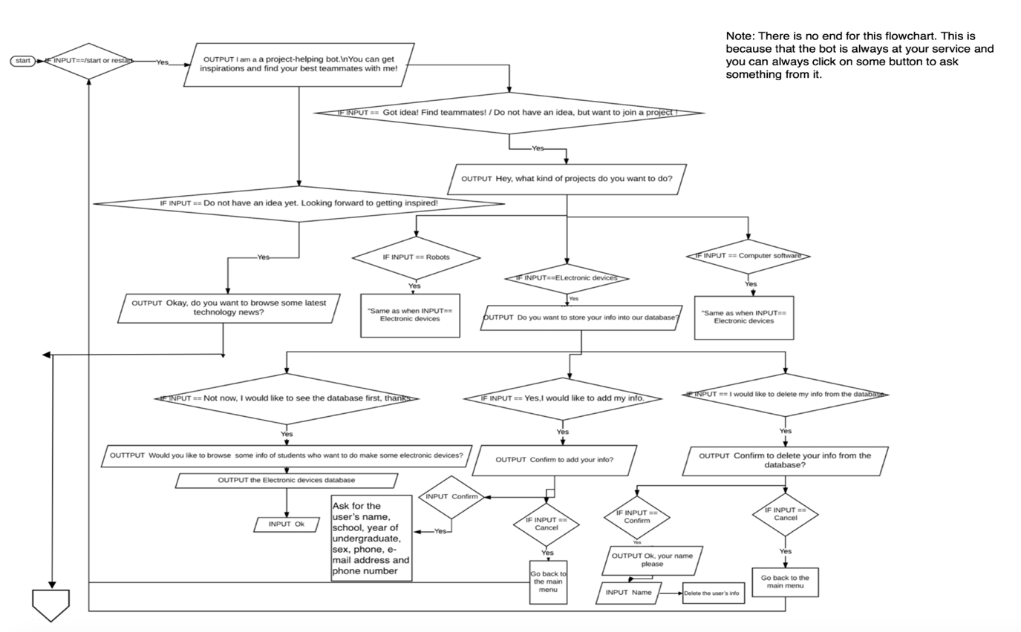

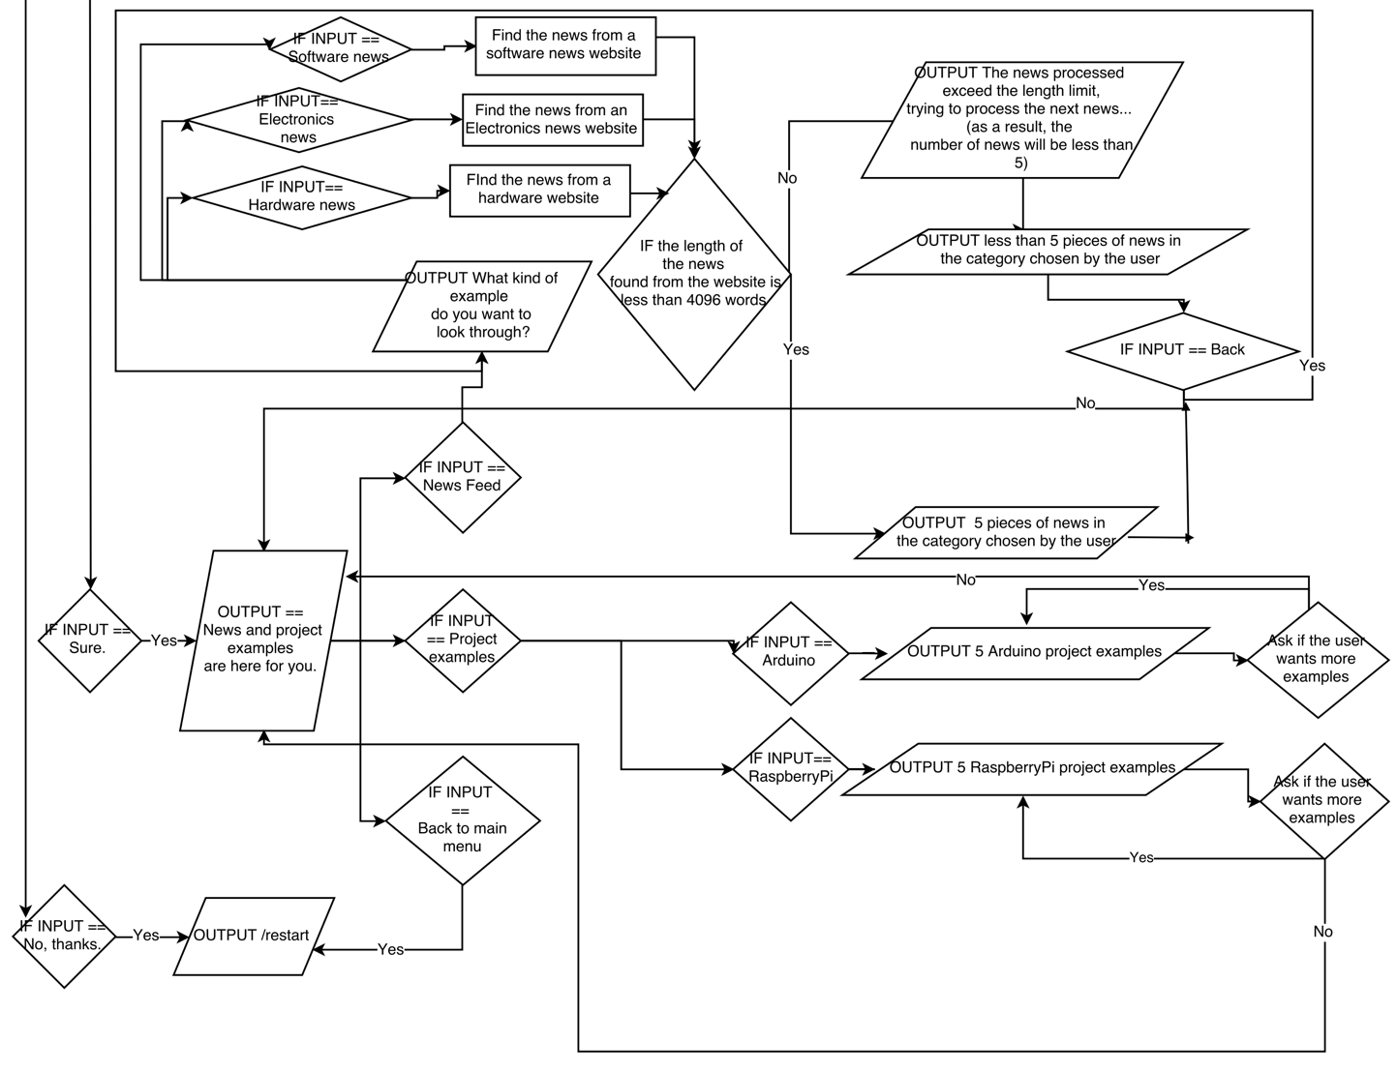

*Figure 1. “NTU Project Accelerator” Telegram Bot Flowchart*

# 3.2 Functions

**3.2.1 “Technology News and Project Examples” Function**

The purpose of our bot’s “prompting technology news and project examples”, is mainly to help users who could not come up with brilliant project ideas and would like to get inspired by some latest technology news. It also serves as a platform to connect students to existing project proposed by the rest of their cohort mates.

Our bot can prompt three categories of technology news: software, electronics and hardware to our users. And each piece of news can be displayed in two formats for users to choose: title + URL and title + date + full news text. The technology news can be displayed one piece at a time and there are five pieces in total. The users can refer to the user manual attached to this report to find out how they can select various technology news and how they can select various technology news format, etc.

What’s more, our bot can also recommend some already proposed project examples for users to get inspire. There are two main categories of project examples: Raspberry-Pi project examples and Arduino project examples, which are really popular topics in the area of electronics hardware industry. Similarly, these project examples are prompted one piece at a time. The bot is able to display 5 set of news concurrently. Then the users can choose to view five more examples. After all the examples in the website are displayed, the users will be automatically returned to last menu. The users can refer to the user manual attached to this report to find out how they can select various project examples and how they can view them, etc.

All the technology news and project examples are collected real-time from the internet by BeautifulSoup functions.

**3.2.2 “Find Project Teammates” Function**

What’s more, our bot can also serve as a platform for users, mainly for NTU students to find their teammates if the students already have a genius idea in mind but are unable find suitable teammates to share their brilliant ideas and to collaborate.

Our bot will firstly query what kind of project the users would like to do. The users can choose from three categories: electronic devices, computer software and robots. Accordingly, our bot provides three main databases: electronic devices, computer software and robots. Each database is related to the kind of project the users would like to do.

For each database, the users have rights to add their personal information to the database, read others’ information from the database and delete their personal information from the database.

When adding the personal information including project category, name, school, study year, sex, contact number, email and project idea to the database, the process is step by step, which means that, the users can edit a certain piece of information many times when adding it. Once the users confirm the information, the users can press the inline keyboard button to proceed to next step. A detailed user manual is attached to this report to guide the users to use our “finding teammates” function step by step.

In order to protect the databases from being abused by the users, we have developed an algorithm to make sure that each user can only add one set of information in each database.

The operations related to the databases are achieved by handling the csv files. Most importantly, we make our bot chat with users separately, which means each user can use our bot at the same time and receive separate message from the bot.

# 4. Limitations & Constraints

Due to time constraints, below mentioned are some limitations on the Project Accelerator that affects the user friendliness of the bot. After various test on the bot the team had identified the limitations and wish to solve it if more time was given.

**4.1** Given the text limit of Telegram which is capped at a maximum message length of 4096, our team coded the bot in a way that the program can detect news that’s beyond the text limit and exclude the particular news to avoid errors. However, this limit the type of news that can be viewed from the bot. Imagine yourself scrolling for news on a mobile application and the application filters out most of the news that are more informative?

**4.2** At some instances, the websites that the news will be retrieved from might be under maintenance, which in bot not being able to fetch any news when requested. Not to ignore the fact that news updates on Raspberry-Pi and Arduino are also updated very rarely. This might lead to circumstances when the news tends to be repetitive.

**4.3** The lack of flexibility can be experience while using the program. Users must obey fixed steps that is already pre-programmed, in order to add personal information to the database. At every step for the addition of information, the inline keyboard must be used so as to proceed to the next input of information. This is deemed as an issue that seem to affect the user friendliness of the bot.

**4.4** The bot was not program in a way that allow users to edit user’s information that were already upload. The only solution for the user was to delete the particular info, re-enter and upload their particulars again. This proves to be rather inconvenient for users which might lead to the unwillingness in using our bot in a long run.

**4.5** The programming fashion of our bot only allows every user to upload one set of personal information onto the database at the moment and they are not allowed to edit the particular uploaded information intuitively. Editing of particulars is only possible if the user deletes the previous set of particulars and input a new one. This limitation will lead to various issues which will be further explain in the points below.

**4.6** The group identified that information uploaded onto the database can be deleted by any user who is aware of the author’s username. Given the time constrain our group did not manage to program the bot whereby it could create a unique user identification for every user that uses the program that will greatly improve the security of the information. This limitation also give rise to various program issues which might end up preventing some users to be unable to upload any information onto the database. As a random user could have just use the person’s name and delete their information. This result in the actual user not being able to upload anything onto the database because the data was not deleted by him. The team do not rule out the possibility of such a situation, as pranks or sabotaging is not something uncommon.

# 5. Conclusion

After personally testing the bot and also gathering feedbacks from friends who have tried our bot, our team hopes to improve the user friendliness and also the reliability of the bot program if given more time. Below are some of the possible improvements to target the indicated limitations and constrains as stated in the above section of the report.

**5.1** To counter the issue of the having to re-enter the whole section of the particulars. A better possible way will be having an in-line keyboard selection choices for types of particular that the user would like to alter. Such a function would prove to be far more user friendly and less time consuming.

**5.2** For the limitation regarding the security breach of users’ particulars, we can program it in this way that every user is given a unique user identification. This is to make sure only the particular user with that particular phone number can access the account and perform the changes. There might be other forms of method where password can be linked to the particular user’s info to further secure the privacy of the user.

**5.3** With regards to the reliability of generating news from the website. In an event of a website maintenance or repetitive news, our team have thought improving the program by fetching more news from various website links instead of the current one. Which will increase the reliability of the bot.

In conclusion, from this project we learn that creating a simple bot like this also require various rounds of fine tuning. We also have to understand how the program will work when it faces various different inputs from the wide range of users. In such sense that initial written program might not have expected certain inputs which might give rise to errors. We also have to go through the whole phase of mental processes from identify and extract the main concepts of the program, to creating the instructions to solve the problem. Also, to break down processes into parts and putting them onto programs which allows the program to perform repetitive task as desired. From this Telegram bot project, we got to learn how to put the programming functions we learnt in our everyday lectures to actual use. It’s really an eye opener on how much work have to be put through at the back end, for the apps in our smart phones to run smoothly.